Reverse Engineering and Protection Analysis: OWASP UnCrackable Level 1
Jaxon Doolittle
Georgia Southwestern State University
CSCI 6130: Mobile Security
Dr. Jonathan Hobbs
June 23, 2026

Safety and Ethics Statement
The techniques and analysis detailed in this report were performed on an isolated Android emulator environment using an intentionally vulnerable APK provided by OWASP for educational purposes. No live production applications, unauthorized systems, or intellectual property were attacked, modified, or decompiled during this exercise.

1. Environment Setup & Static Analysis (MobSF)
This week’s lab transitions from broad vulnerability scanning into actual reverse engineering. To kick things off, I spun up the Mobile Security Framework Docker container to establish a baseline. After uploading UnCrackable-Level1.apk, MobSF analyzed the application metadata, revealing the package name owasp.mstg.uncrackable1, targeting SDK 28 with a minimum SDK of 19.
Interestingly, MobSF gave the app a Security Score of 55/100 (Grade B - Medium Risk). Relying purely on this automated score would give a false sense of security. It relies entirely on "security through obscurity" by trying to hide its validation logic on the client side.

Permission Analysis
Based on previous lab feedback, I conducted a full review of the application's requested manifest permissions and categorized them by risk. Unlike last week's highly invasive banking application, UnCrackable Level 1 has a heavily restricted permission footprint:
Permission | Category | Justification
(None explicitly requested) | Necessary (Baseline) | The application operates entirely locally as a standalone cryptographic challenge. It does not request INTERNET, READ_EXTERNAL_STORAGE, or any telephony permissions, strictly adhering to the principle of least privilege.
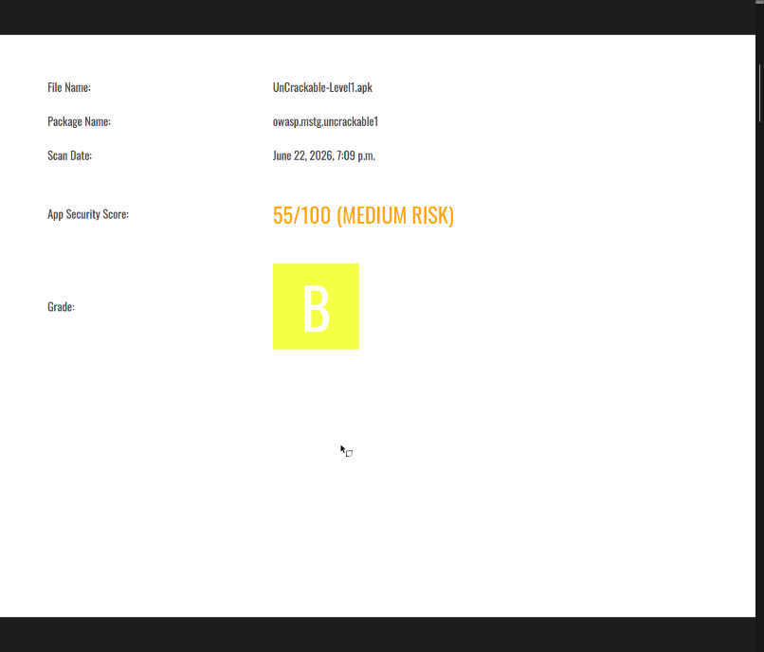
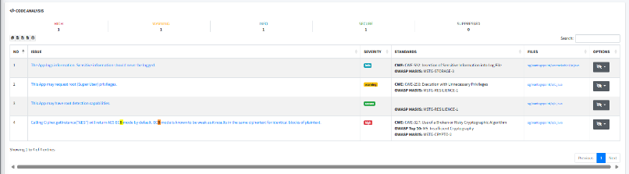
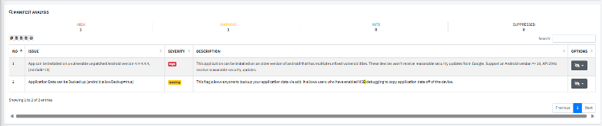

2. Code Analysis & Reconstructing the Defenses (Jadx)
To figure out how the app actually works under the hood, I pulled the APK into Jadx-GUI. This tool essentially strips away the compiled Dalvik bytecode and rebuilds the human-readable Java source code. By expanding the sg.vantagepoint.uncrackable1 package, I located the MainActivity class.
Reading through the Java code, it is clear that the developers built a digital obstacle course. Before the user can even attempt to type in the secret password, the app runs four distinct environmental checks. If any of those checks fail, it throws an AlertDialog and violently terminates the app process using System.exit(0). If you survive the checks, the verify (View view) method intercepts your input and passes it into a separate class for cryptographic comparison.

Protection Logic Map
Based on my analysis of the Jadx decompilation, here is the exact execution flow of the application's client-side protections:

[App Launch]
↓
MainActivity.onCreate() executes
↓
[Root & Environment Checks]
Calls static methods c.a(), c.b(), c.c() to hunt for Root indicators
Calls static method b.a() to hunt for an active Debugger
↓
[Decision Fork]
├── IF ANY CHECK = TRUE:
│ → MainActivity.a() triggers
│ → Displays "Root detected!" or "App is debuggable!" Alert
│ → User clicks "OK" → System.exit(0) kills the app.
│
└── IF ALL CHECKS = FALSE:
→ setContentView(R.layout.activity_main) loads the UI
→ User interacts with the app
↓
[User Input Collection]
User types secret into EditText (R.id.edit_text) and clicks VERIFY
↓
[Validation Logic]
MainActivity.verify() passes the input string to a.a()
↓
[Result Display Fork]
├── IF a.a() = TRUE: Displays "Success! This is the correct secret."
└── IF a.a() = FALSE: Displays "Nope... That's not it. Try again."

3. Required Evidence Table
Obs # | Tool Used | Class / Method / Location | Evidence Found | Security Meaning | Why It Matters
1 | Jadx | MainActivity.onCreate | c.a() || c.b() || c.c() | The app calls three distinct methods to detect root access right at startup. | Acts as the primary gatekeeper, preventing compromised devices from analyzing the app.
2 | Jadx | MainActivity.onCreate | b.a(getApplicationContext()) | Checks if a debugger is actively attached to the application. | Prevents reverse engineers from stepping through memory at runtime (e.g., using JDB).
3 | Jadx | MainActivity.a | System.exit(0) | If checks fail, the app forcefully kills its own process. | This is a weak defense; an attacker can easily hook and disable this exit command using Frida.
4 | Jadx | MainActivity.verify | a.a(string) | The verification of the user's string is passed to an external utility method. | Centralizes the validation logic, giving an attacker a single function to reverse engineer.
5 | MobSF | Code Analysis | AES/ECB/PKCS7Padding | The app uses Electronic Codebook (ECB) mode for its cryptographic checks. | ECB is a weak encryption mode that fails to hide data patterns, making cryptographic reversing easier.
6 | MobSF | App Metadata | Target SDK: 28, Min SDK: 19 | Application metadata parsed from the manifest. | Tells an attacker exactly what API rules and Android security restrictions the app operates under.
7 | Jadx | sg.vantagepoint.a.c | Checks for /system/xbin/su | The c.a() method looks for the standard su binary pathway. | Hardcoded file path checks are easily spoofed or bypassed by modern root-hiding tools like Magisk.
8 | Jadx | sg.vantagepoint.uncrackable1.a | Hardcoded AES Keys & Secrets | The secret validation logic contains hardcoded Base64 keys inside the Java class. | The ultimate failure: storing the lock and the key on the client side allows anyone to read the password.

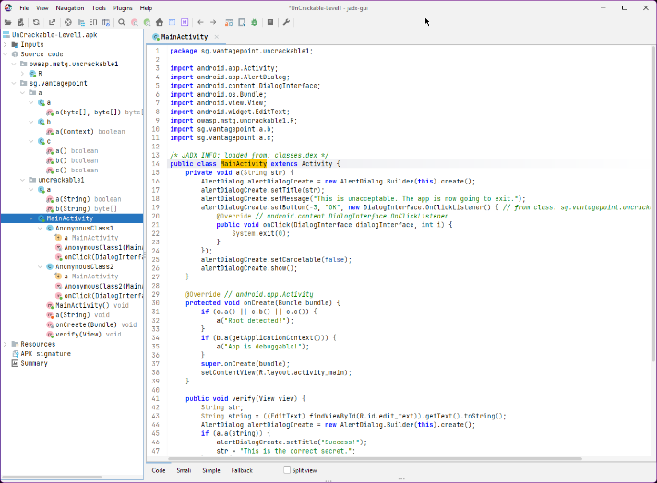

4. Analysis of Root & Environment Checks
Mobile apps frequently try to detect if they are running in a hostile environment, and UnCrackable Level 1 is no exception. Inside MainActivity.onCreate(), the app calls c.a(), c.b(), and c.c().
By digging into the sg.vantagepoint.a.c class in Jadx, we can see exactly what these checks are doing.
- The Conditions: The app scans the System.getenv("PATH") for the su binary, checks system build properties for test-keys (which usually means a custom, non-stock kernel), and looks for known root management applications or binaries like Superuser or daemonsu.
- The Response: If any of these conditions return true, the app triggers the MainActivity.a() method. This method throws the "Root detected!" pop-up. The moment the user clicks "OK", the app executes System.exit(0) to commit suicide and close the process.
- The Weakness: While these root checks are a decent "speed bump" for normal users, they are completely unreliable against a skilled attacker. Because the checks are running locally on the phone, tools like Magisk (MagiskHide) can intercept the app's request to view the file system and lie to it, saying the su binary doesn't exist. Alternatively, an attacker can use a dynamic instrumentation framework like Frida to hook the c.a(), c.b(), and c.c() methods in active memory and force them to always return false, bypassing the check entirely without even modifying the APK.

5. Analysis of the Secret Validation Logic
If an attacker bypasses the root checks, they are presented with a text box. When the user types a string and clicks "Verify," the input is captured in MainActivity.verify() and passed directly into the a.a(string) method for evaluation.
- The Cryptographic Flaw: Inside the sg.vantagepoint.uncrackable1.a class, the logic takes the user's input and compares it against a highly guarded secret. However, the secret is not verified against a secure server. Instead, the developers took the actual plaintext password, encrypted it using AES (ECB mode), and hardcoded the resulting cipher text into the app. Crucially, they also hardcoded the Base64 AES decryption key right next to it.
- Why Client-Side Validation Fails: Storing validation logic inside the client application is fundamentally flawed architecture. The client app is an untrusted environment controlled entirely by the user. Because both the encrypted password and the decryption key are sitting in the Java bytecode, any attacker with Jadx can simply copy the key, run it through a standard AES decryption script (like CyberChef), and read the plaintext password ("I want to believe"). If the app can decrypt the string to check your input, the reverse engineer can too.

6. Dynamic Analysis & Runtime Observation
To confirm the static findings, I deployed the unmodified APK to a fresh x86 Android Emulator instance.
- Upon launching the application, I was immediately greeted with an un-dismissible AlertDialog stating: "Root detected! This is unacceptable. The app is now going to exit."
- Because the emulator image is fundamentally built differently than a stock commercial phone (containing test-keys and running on an x86 architecture), the environmental checks in MainActivity.onCreate() instantly flagged the device as hostile.
- Clicking "OK" verified the System.exit(0) code path, forcefully crashing the app back to the Android home screen, confirming that without dynamic instrumentation (like Frida) or a heavily customized non-root emulator, interaction with the verify() logic is physically blocked.

7. Defensive Lessons Learned
Reverse engineering this application highlights exactly how not to build mobile security controls. First, never trust the client. Client-side secrets are inherently broken. If your application contains the logic to decrypt a secret, an attacker can extract that exact same logic. Next, obfuscation is just a speed bump. This app lacked obfuscation (like ProGuard), which made reading the Jadx output incredibly easy. However, even if the code was obfuscated, it only slows a reverse engineer down, it does not stop them from extracting hardcoded keys. Root detection is a cat-and-mouse game. Root detection is a great layer of defense-in-depth to stop automated malware or script kiddies, but it should never be relied upon as the primary security mechanism. It is always bypassable because the attacker controls the OS. Finally the right way. Stronger design dictates that sensitive validation must occur server-side. The app should take the user's input, send it over a pinned TLS connection to a secure backend server, and the server should respond with a simple session token or a success/failure flag.

8. Reflection Questions
1. What was the most important class or method you found, and why?
MainActivity is the most important class. It acts as the central gatekeeper, serving as the orchestrator that triggers the root/debugger defenses, handles the UI events, and routes the user's input directly to the cryptographic validation classes.
2. What was the most useful tool in this lab: MobSF, Jadx, or runtime testing? Explain your answer.
Jadx was undeniably the most useful tool. MobSF is great for finding low-hanging fruit, but Jadx allowed me to read the actual Java source code, trace the application's logic path, and see exactly how the root checks and cryptography were implemented.
3. What part of the app protection was easiest to understand?
The root detection logic in MainActivity.onCreate() was incredibly straightforward. Seeing the simple boolean if (c.a() || c.b() || c.c()) { a("Root detected!"); } made it very easy to understand the application's self-destruct mechanism.
4. What part of the app protection was hardest to understand?
Tracing the cryptographic validation logic inside the a.a class was slightly more complex. Deciphering how the app took the hardcoded strings, converted them from Base64 into byte arrays, initialized the javax.crypto.Cipher, and evaluated the arrays required a deeper understanding of Java cryptography implementations.
5. How could a developer make this type of reverse engineering more difficult?
A developer could make this vastly more difficult by implementing the security checks in native C/C++ code using the Android NDK (Native Development Kit). Decompiling compiled native .so libraries in Ghidra or IDA Pro requires reading assembly language, which is exponentially harder than reading Java in Jadx.
6. Why should developers avoid storing important secrets or validation logic entirely inside a mobile app?
Because the mobile device is fundamentally a "zero-trust" environment. The attacker owns the phone, the memory, the operating system, and the application binary. Anything stored locally can, and eventually will, be extracted by a determined reverse engineer.
AI Use Statement: Generative AI was utilized to assist in creating an initial outline, as well as formatting the illustration. All technical analysis, tool execution, and code evaluations were derived directly from hands-on lab work.

